At Penn graduations, a dearth of female speakers
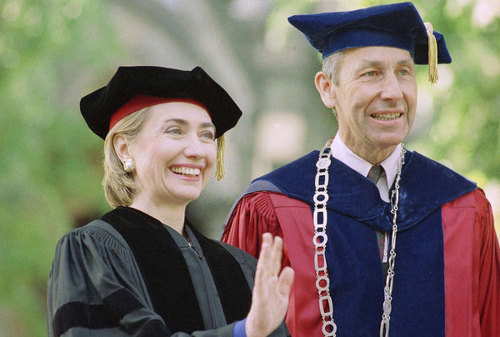
Hillary Clinton gave the commencement speech in 1993, during the tenure of Sheldon Hackney (right) as Penn's president. (AMY SANCETTA / Associated Press)
By Susan Snyder, Inquirer Staff Writer
May 27, 2014
A woman has led the University of Pennsylvania for the last decade, but when it comes to commencement speakers, just about all have been men.
Actress Jodie Foster addressed graduates in 2006 - the only woman since Amy Gutmann became president a decade ago.
Only five women have had the honor in the last 30 years, though more than half Penn's students are women.
"Wow! It's unfortunate that we are not putting female role models in front of those graduates at every opportunity, and this is one of those opportunities," said Lois Ferguson, president-elect of the North American Association of Commencement Officers (NAACO), a professional association of college commencement and convocation officers.
At Penn, some students and faculty decried the trend in a March article in the student newspaper, the Daily Pennsylvanian.
"The last time we had a woman commencement speaker, I was wearing braces and I had a bedtime," Madeleine Stevens, 21, a senior from Philadelphia, said last week.
Stevens, a communication and public service major and president of the Women's Political League at Penn, spotted the lack of female speakers while working on a project for Penn Women's Center during the summer of 2012.
"It's quite disappointing that our most famous and important speaker position every year is a man," she said.
Penn officials called the trend coincidental.
"We are aware that there have been fewer women than we would otherwise hope," said Stephen MacCarthy, vice president for university communications, "and have every expectation that that will even itself out in the years ahead."
While other elite universities, too, have traditionally feted few women, several have brought in more over the last decade than Penn.
Harvard hosted Oprah Winfrey, Harry Potter series author J.K. Rowling, and Liberian President Ellen Johnson Sirleaf. Princeton, Yale, Stanford, Dartmouth, and Cornell, too, have had more than one woman as speaker in the last decade.
Dartmouth has hosted TV producer Shonda Rhimes; Wendy Kopp, CEO of Teach for America; author Louise Erdrich; and Sirleaf.
Cornell has welcomed Rep. Nancy Pelosi, poet Maya Angelou, and journalist Soledad O'Brien, while Princeton has had Brooke Shields and Katie Couric. Barbara Walters and U.S. Rep. Eleanor Holmes Norton have spoken at Yale. Bill and Melinda Gates gave a joint address this year at Stanford, which also has featured Winfrey and Susan E. Rice, national security adviser.
At Penn, the commencement speaker is selected by a committee of the board of trustees, chaired by veteran NBC News anchor Andrea Mitchell. Ten of its 13 members are men. Gutmann is on it.
MacCarthy said the committee considers about 20 new nominations a year from students and others. Nominations from previous years can carry over.
A speaker, according to Penn guidelines, must be a "distinguished individual" and "an accomplished public speaker" who exemplifies "the highest ideals of the university, which seeks to educate those who will change the world through innovative scholarship, scientific discovery, artistic creativity and/or societal leadership."
Penn has selected four black speakers in the last 10 years: Denzel Washington; Kofi Annan; Geoffrey Canada, founder of the Harlem Children's Zone; and this year, singer and songwriter John Legend, who spoke to the 5,000-plus grads Monday.
"If it were all white men, it would probably bother me," said Marybeth Gasman, a Penn education professor who specializes in the study of colleges serving primarily minority students. "Having African American males was really, really important. But it is important that there be gender diversity, too."
Camille Z. Charles, professor of sociology and Africana studies and a past faculty senate chair, said diversity should not be thought about "one characteristic at a time.
"I would love to see not only women, but women of color," she said.
The dearth of women did not start with Gutmann. There was only one during president Judith Rodin's 10 years - Jane Alexander, chairwoman of the National Endowment for the Arts, in 1995. Under Sheldon Hackney, Rep. Patricia Schroeder spoke in 1988, Barbara Bush in 1990, and Hillary Rodham Clinton in 1993.
"There is a big disparity," said Joyce Kim, 20, a senior and student body president. But, she said, she would not want a woman selected just because of her sex.
"If there is a speaker whom students really want and who is particularly relevant and he happens to be male," that shouldn't be held against him, said Kim, a political science major from Allen, Texas. "But I think it would be awesome if we had a female."
Stevens cited several possibilities, including Supreme Court Justice Sonia Sotomayor; novelist Toni Morrison; Tina Fey; Samantha Power, U.S. ambassador to the United Nations; and Kerry Washington, star of Scandal. She said she would push to get a woman selected for 2015.
"I have a special investment," she said, "because it's my commencement."

