Astronaut sky high on list of best graduation speakers

August 1, 2014
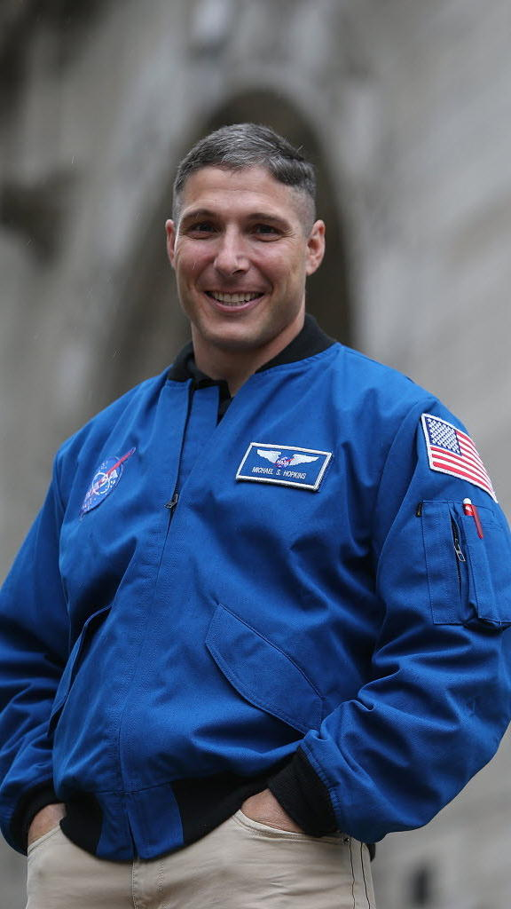
Antonio Perez/Chicago Tribune
By Marwa Eltagouri, Tribune reporter
This year’s University of Illinois at Urbana-Champaign commencement speaker – who received a standing ovation from the 17,000 people attending the ceremony – earned a spot on a list of the top graduation speeches of the season.
Michael Hopkins, an astronaut and U. of I. alum, had returned from a 166-day mission on the international space station just before giving his address, which emphasized the importance of perseverance. The North American Association of Commencement Officers listed Hopkins as one of the six best speakers of 2014.
“These speakers are the kind of people you want at commencement,” NAACO president Lois Ferguson said Friday. “They’ve proved themselves to be successful, they have a story to tell, and they’re engaging to students, parents, family and alumni.”
Other top speakers were President Barack Obama, who spoke at the University of California-Irvine, and Susan Wojcicki, YouTube’s CEO, who addressed Johns Hopkins University’s graduates, according to the group.
The list isn’t all high-profile names, though. Ferguson said one of the best speeches was given at Philadelphia University by Nicholas Christian, one of the university’s graduates. He delivered his speech dynamically, exploring the question of destiny with his fellow graduates and telling them how their destinies were “rich with innovation, collaboration and ideas that will change the world.”
He too received a standing ovation from the ceremony’s 6,000 attendees.
“Sometimes you do want a big speaker. The president, or the president of a major corporation, or an actor or actress,” Ferguson said. “But sometimes you just want to put in front of the students someone who graduated from the university, who aren’t necessarily well-known but still have excellent lives.”
Other speakers on the list included John Quiñones, a news correspondent for ABC who spoke at the University of Washington Bothell, and Lewis Katz, a philanthropist who spoke at Temple University.
Quiñones shared with graduates the story of his rise from a poor family of migrant workers to ABC’s first Latino correspondent, urging graduates to push past socio-economic barriers.
Katz spoke of the importance of living an enjoyable life. He died in a plane accident a few weeks after the ceremony, and his commencement remarks were highlighted in his memorial service at the university.
“It’s these people who make commencement a fabulous and memorable experience,” Ferguson said.
http://www.chicagotribune.com/news/local/breaking/chi-astronaut-sky-high-on-list-of-best-graduation-speakers-20140801-story.html

