Campus Inq

Lewis Katz recognized as top 2014 commencement speaker
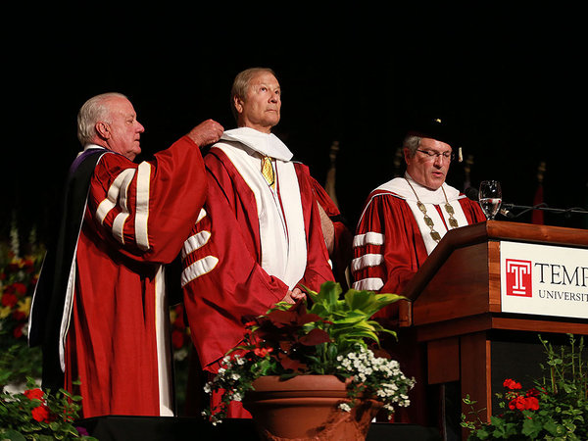
Lewis Katz, co-owner of The Inquirer who died in a plane crash May 31, has been recognized by a national organization as being the top commencement speaker in 2014. He spoke at his alma mater, Temple University. DAVID SWANSON / Staff Photographer

Susan Snyder
August 1, 2014
As commencement speakers went this season, the late Lewis Katz - former co-owner of The Philadelphia Inquirer — topped the list, as ranked by the North American Association of Commencement Officers.
Katz, a lawyer, businessman, and philanthropist, died in a plane crash May 31, just a few weeks after he delivered the commencement address to graduates of his alma mater, Temple University.
On Friday, Katz was listed by the organiziation — a professional association of commencement and convocation officers from colleges and universities throughout North America - as one of six speakers who “went above and beyond this year to deliver an inspiring and unforgettable spring and summer commencement address.”
Also selected as one of the six was star scholar athlete Nicholas Christian, the graduate who spoke at Philadelphia University’s commencement.
More coverage

Lewis Katz's 2014 commencement address at Temple University
"A commencement speaker delivers the final and perhaps one of the most important messages students will hear in their academic career. Such a task is not to be taken lightly and it's great to see how many speakers have truly made an impact," NAACO Past President Linda Bekerian said in a prepared statement. "To be able to make an impression on the graduates, their families and the academic community speaks volumes about each and every one of these individuals."
Excerpts from Katz’s commencement speech were played at the memorial service held for Katz at Temple on June 4. Bill Clinton, former governor Ed Rendell, Sen. Cory Booker, Mayor Nutter, Gov. Corbett, historian Doris Kearns Goodwin, Inquirer editor William K. Marimow, and comedian Bill Cosby, were among those who spoke at the service.
“Life in my view is meant to be enjoyed,” Katz, also a former member of Temple’s board of trustees, told graduates. "It's meant to have as much fun as you can conjure up."
Katz closed with the words of UCLA basketball coach John Wooden: "You can't live a perfect day without doing something for someone who will never be able to repay you."
Here’s a link to Katz’s speech:
https://www.youtube.com/watch?v=ynwA-gVnpbM&list=PLwxXcOKHPC0luNqmpYD6RFOp9d2mekxkg
Christian, of Bensalem, drew a standing ovation from 6,000 university graduates, faculty, family and friends at Philadelphia University’s commencement.
“My fellow classmates, what is our destiny?" Christian asked fellow graduates. "It is rich with innovation, collaboration and ideas that will change the world. Our destiny is not in question. We say to our friends and our families, to our future and everything that tries to block it, our destiny is greatness!"
Philadelphia University President Stephen Spinelli Jr. noted in his June 18 blog post that Christian was moving to Florida to start a career with Comcast: “In my 21 years in higher education, this was the first time I saw a student speaker receive a standing ovation for his or her remarks at a commencement,” Spinelli wrote.
Here is a link to Christian’s speech: https://www.youtube.com/watch?v=6VM6X01NsoU
The other four speakers who rounded out the list are: Susan Wojcicki, CEO of YouTube, Johns Hopkins University; President Obama, University of California, Irvine; Colonel Michael Hopkins, an astronaut, the University of Illinois; and John Quiñones, ABC News Correspondent, University of Washington Bothell.
http://www.philly.com/philly/blogs/campus_inq/Lewis-Katz-recognized-as-top-2014-commencement-speaker.html#otmu0O9RbCkdM8Fc.99

