OWLSPORTS – Temple University Athletics

Temple Football Honors Lewis Katz with Commemorative Patches

8.28.14

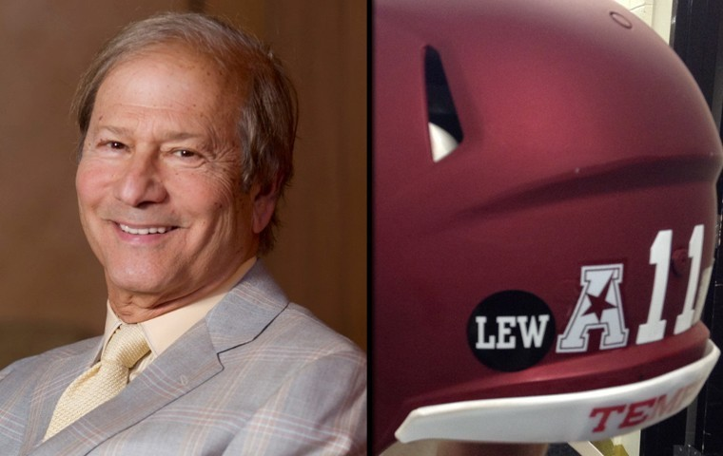

Lewis Katz Commencement Speech (video)
PHILADELPHIA - The Temple University football team will honor the memory of long-time Board of Trustee member Lewis Katz this season with commemorative "Lew" patches on the players' helmets.
Katz, a vibrant member of the Temple community from his time as a student in the early 1960s to his receipt of an honorary degree on May 15, 2014, was killed May 31, 2014, in a plane crash. Katz had served as a Temple trustee since 1998. He is known for his long-time support of student scholarships, athletics, entrepreneurship and medicine.
"Lewis Katz was a tremendous leader, supporter, and believer in Temple and Temple athletics," extolled Temple football coach Matt Rhule. "His impact is missed both here on campus and throughout all the communities he touched with his many business and philanthropic endeavors. I wish he was with us here at the game. These decals are just one way for us to let people know he's always with us."
Katz, CST '63, made a lasting impression on his alma mater, and his final words to the Temple community were perhaps his most profound. Those words, which were delivered during Temple's 127th Commencement exercises, earned the highest honor a Commencement address can receive. The North American Association of Commencement Officers (NAACO) posthumously named Katz the best commencement speaker of 2014.
In a career that spanned the fields of law, investment banking and business, Katz served as partner in the law firm of Katz, Ettin and Levine, where he led a variety of enterprises including Kinney Parking Systems, the New Jersey Nets, the New Jersey Devils, Philadelphia Media Network and Interstate Outdoor Advertising.
Katz also was director of the Katz Foundation—which supports charitable, educational and medical causes. Katz also has served on the boards of the Boys & Girls Clubs of America and the National Basketball Association.

http://www.owlsports.com/news/2014/8/28/FB_0828144014.aspx

