CAMPUS LIFE: Late Katz named best commencement speaker
Phil Dunn

August 17, 2014

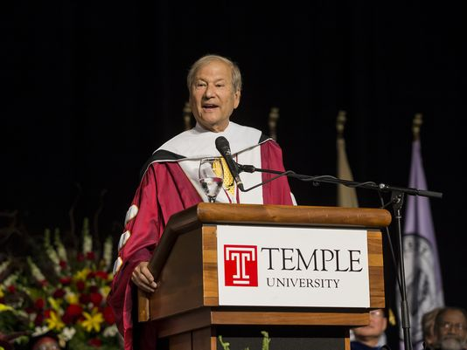
(Photo: Temple University Photography)
Graduates from Temple University watched and listened intently as Lewis Katz spoke at commencement in May.
His message was one of hope and inspiration, but he also challenged the graduates to never forget that life is about having fun.
MORE: Remembering Lewis Katz
That speech was one of the last the millionaire entrepreneur would give. The 72-year-old died May 31 when his private jet exploded during takeoff outside Boston.
The North American Association of Commencement Officers (NAACO) has posthumously named Katz the best commencement speaker of 2014.
He was one of five commencement speakers to be honored by NAACO. Among others were President Barack Obama and YouTube CEO Susan Wojcicki.
"Lewis' speech at that commencement ceremony was among the most inspiring ever given," said Patrick J. O'Connor, chairman of Temple's Board of Trustees.
"His humor, along with stories of his path to success in business and in life, moved our graduates to their feet. It was one of the proudest days of his life."
In his speech, which was given after accepting an honorary doctorate from Temple, Katz told graduates his life story: growing up without a father; working to put himself through college; taking chances in his first investments; and what he learned after a career in business, sports and journalism.
Standing in front of the graduates, Katz told them his business success was not the most important part of his life. Instead, it was his family and friends whom he cherished.
"Life in my view is meant to be enjoyed. It's meant to have as much fun as you can conjure up."
http://www.courierpostonline.com/story/news/local/south-jersey/2014/08/16/campus-life-late-katz-named-best-commencement-speaker/14173023/

