Get Schooled: The Must-Read Edu Stories You Missed Out on This Week
Molly Greenberg - Senior Writer, Higher Ed Beat
08/10/14

Image via Flickr/Kate Ter Haar (CC BY 2.0)
Welcome to "Get Schooled," where we bring you the must-read education articles you probably missed out on this week. Whether you want to know how to get hired by Google, or are just interested in a hilarious YouTube video geared toward the college crowd, here's a curated list of the best-of-edu links from around the Web.
- A new study from Gallup shows that those with student debt claim they have worse health and greater financial stress long after they complete their degree.
- A professor of education and associate dean at the University of Virginia's Curry School of Education will present a report reviewing current research and literature on global efforts to prevent behavioral and mental health problems in kids to the United Nation's as a part of the U.N.'s annual international Youth Day observance.
- Maryland-based edtech company 2U was named to Inc.'s list of 10 tech companies helping humanity. Click here to find out why.
- A group of entrepreneurs from the University of Virginia launched an online food ordering business that has experienced great success in Charlottesville and beyond.
- The North American Association of Commencement Officers chose six speakers who gave "inspiring and unforgettable speeches" in spring of 2014, and named Johns Hopkins speaker and YouTube CEO Susan Wojcicki's among them.
- Darden Executive Education will offer its first-ever fully online class called called Design Thinking for Innovative Problem Solving: A Step-by-Step Project Course this fall in partnership with NovoEd.
- Check out the most hated college football team in each state. Look at Vermont in particular:
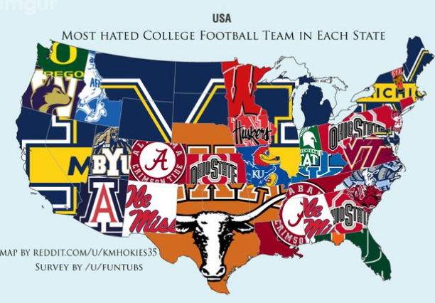
- InTheCapital also published some education articles worth reading this week, including: "11 Unconventional Social Media Concepts You Can Use to Build Your Résumé," "According to The Princeton Review, There are No Major Party Schools in the DC Area," "A Johns Hopkins Engineer Designed Pollution-Hunting Underwater Robots," "How One DC Startup is Helping International Students Navigate the U.S. Admissions Process," "Georgetown Law Professor Tapped to Serve as Counsel to VP Biden," "The 10 Richest Colleges in the D.C. area," "2U Increases Revenue Expectations for 2014," "Is Google Trying to Take Over the Virtual College Tour Space" and "Former Virginia Tech Professor Loses New Job Over Anti-Israel Tweets."
http://inthecapital.streetwise.co/2014/08/10/dc-college-news-education-news-you-missed-out-on-this-week-14/

