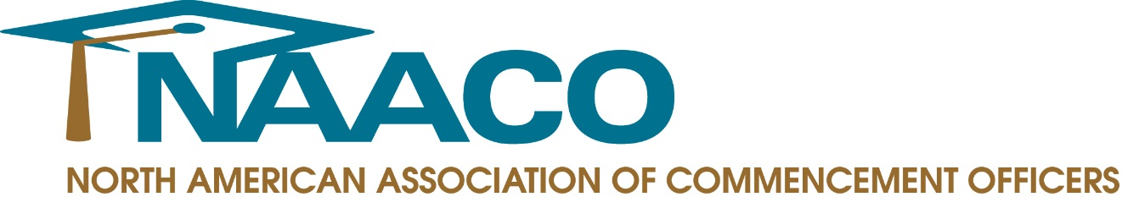

FOR IMMEDIATE RELEASE

Contact: Meghan Higgins
Communications Account Executive
(609) 297-2218
mhiggins@cmasolutions.com

NAACO Members Weigh-In On Best Commencement Speakers of the Season

PRINCETON JUNCTION, N.J. – August 1, 2014 – Now that the caps have been thrown and the tassels have been turned, members of the North American Association of Commencement Officers (NAACO) are reflecting on a memorable spring and summer commencement season.

“A commencement speaker delivers the final and perhaps one of the most important messages students will hear in their academic career. Such a task is not to be taken lightly and it’s great to see how many speakers have truly made an impact,” said NAACO Past President Linda Bekerian. “To be able to make an impression on the graduates, their families and the academic community speaks volumes about each and every one of these individuals.”

According to NAACO members, below are some of the speakers that went above and beyond this year to deliver an inspiring and unforgettable spring and summer commencement address.

Lewis Katz, Philanthropist & Temple University Trustee, Temple University – “Life in my view is meant to be enjoyed,” said Katz, who spoke to Temple’s graduates. “It’s meant to have as much fun as you can conjure up.” Katz closed by recalling the words of UCLA basketball coach John Wooden: “You can't live a perfect day without doing something for someone who will never be able to repay you.” Tragically, Katz passed away in an airplane accident just a few weeks after the commencement ceremony. His commencement remarks were the theme of a memorial service held at Temple on June 4.

Nicholas Christian, Philadelphia University Graduate, Philadelphia University –Christian's remarks, delivered in a dynamic voice, was a highlight of this year's commencement ceremony. “My fellow classmates, what is our destiny?” he asked the Class of 2014. “It is rich with innovation, collaboration and ideas that will change the world. Our destiny is not in question. We say to our friends and our families, to our future and everything that tries to block it, our destiny is greatness!” He received a standing ovation from 6,000 university graduates, faculty, family and friends.

Susan Wojcicki, CEO of YouTube, Johns Hopkins University – Wojcicki connected with students, faculty and guests to create a sense of excitement about what the future holds for each of the graduates. Her genuine enthusiasm came through in her remarks. She was a testament to what can happen when you stay humble and take risks.

President Barack Obama, University of California, Irvine – The University was honored to have President Obama as its commencement speaker this June. This year’s commencement ceremony was unique as it was campus wide and it kicked off the institution’s 50th anniversary groundbreaking. It was amazing to have the entire campus and class of 2014, along with President Obama, celebrating this event all together!

Colonel Michael Hopkins, Astronaut, University of Illinois – Hopkins, a proud University of Illinois alum, who had just returned from a 166-day mission on the International Space Station, gave a memorable address about perseverance and received a standing ovation from the 17,000 people who attended the ceremony.

John Quiñones, ABC News Correspondent, University of Washington Bothell – Quiñones shared his powerful story of growing up in a poor family of migrant workers to eventually become ABC’s first Latino correspondent. He encouraged students to pursue their dreams regardless of socio-economic barriers and emphasized the role that education played in his own success.

###

About NAACO
Founded in 2001, the North American Association of Commencement Officers (NAACO) is a professional association of commencement and convocation officers from colleges and universities throughout North America. NAACO is dedicated to providing a community structure for commencement professionals to exchange ideas, share traditions, explore new opportunities and connect with colleagues from around the world who share the monumental responsibility of producing academic ceremonies. For more information, visit www.naaco.org.

