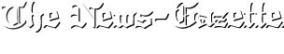

Top of the Morning
08/09/2014

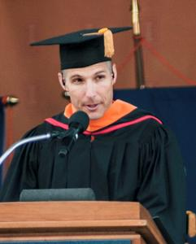
Photo by: Heather Coit/The News-Gazette

NASA astronaut and former Illini football player Mike Hopkins' address at the 2014 University of Illinois graduation in May was named one of the nation's best by the North American Association of Commencement Officers.
Two lists worthy of a second look:
1. The Class of '14 at the University of Illinois wasn't the only group impressed by Mike Hopkins' rousing performance on graduation weekend at Memorial Stadium.
The speech delivered by the former Illini football player and NASA star was named one of the nation's best by North American Association of Commencement Officers. Among his zingers:
— "I am more nervous standing here talking to you than I was stepping out of an air lock to walk in space."
— "This is the first time I've been at the 50-yard line since I played my last game here in 1991."
— "I was turned down (to be accepted to NASA's astronaut training program) in 1998, 2000 and 2004. I figured I would just keep applying until I made it or NASA told me, 'Don't bother.' "
Hopkins joined five others on the list, including President Barack Obama (UC-Irvine). The others: YouTube CEO Susan Wojcicki (Johns Hopkins); philanthropist Lewis Katz (Temple); Philadelphia University grad Nicholas Christian (Philadelphia University); and ABC's John QuiNones (University of Washington Bothell).
Hopkins wowed an estimated crowd of 17,000 attending the UI's first outdoor commencement since 1962.
"Students came specifically to hear him, and they weren't disappointed," said Laura Wilhelm-Barr, director of special events at the UI. "He was inspirational."
2. Lost among the Party School hubbub in the annual Princeton Review college rankings that were released this week was the fact that the UI was voted to have Best Athletic Facilities of 379 candidates. Take that, Texas.
However, it's not just the beauty of Memorial Stadium that led to the top spot. Results were based on students' answers to: "How do you rate the recreational/athletic facilities at your school?" The guess here is the attractions like sand volleyball courts, the immense Activities and Recreation Center (ARC) and the chance to play intramurals on artificial turf pushed the UI ahead of the pack.
http://www.news-gazette.com/news/local/2014-08-09/top-morning-aug-9-2014.html

