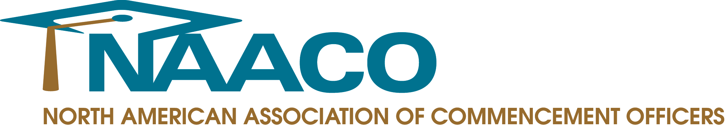

FOR IMMEDIATE RELEASE

Contact: Meghan Higgins, Publicist
Creative Marketing Alliance
609-297-2218
mhiggins@cmasolutions.com

New NAACO President Lois Ferguson Takes Reign

Association Poised for Further Growth with New Leadership

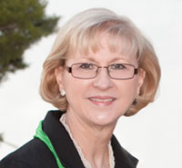
PRINCETON JUNCTION, N.J. – September 17, 2014 – The North American Association of Commencement Officers announced its new president, Lois Ferguson, manager of Commencement and Facilities Planning at Baylor University. In addition, NAACO welcomed several new Board members to help lead the association.

Lois Ferguson has worked at Baylor University since 1988, and she has been responsible for university commencement ceremonies since 1999. She is involved in all areas of commencement, providing guidance and helping with decisions ranging from venue set-up to regalia. She also maintains Baylor’s commencement website and oversees the budget.

“I couldn’t be happier to serve the association as its newest president,” Ferguson said. “I look forward to working with the board to further our efforts in improving commencement and convocation ceremonies at colleges and universities across North America.”

Ferguson will follow former NAACO president, Linda Bekerian, associate director of academic ceremonies at Northeastern University, who will now serve as past-president. She also will be joined by Lisa Walker, director of ceremonies, marketing manager at University of Washington Bothell, who will serve as president-elect; Christine Deehan, director, University Events at Rowan University, who will serve as treasurer and Gabrielle Copperwheat, executive director of NAACO Headquarters.

NAACO also welcomes Suzanne Kahl, commencement coordinator at Tufts University as the association’s new secretary; Brad Coburn, calendar and convocation coordinator at McMaster University and Stephanie Lee, administrative associate, Oakland University as new directors at large and Jill Williams, associate director, Johns Hopkins University as interim director at large.

For more information on NAACO, visit www.naaco.org.

###

About NAACO
Founded in 2001, the North American Association of Commencement Officers (NAACO) is a professional association of commencement and convocation officers from colleges and universities throughout North America. NAACO is dedicated to providing a community structure for commencement professionals to exchange ideas, share traditions, explore new opportunities and connect with colleagues from around the world who share the monumental responsibility of producing academic ceremonies. For more information, visit www.naaco.org.

