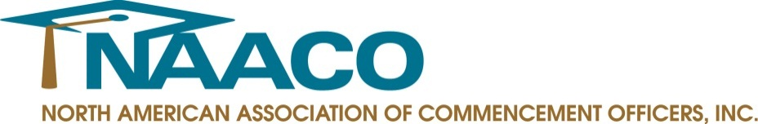
FOR IMMEDIATE RELEASE

Contact: Meghan Higgins
(609) 297-2218
mhiggins@cmasolutions.com

NAACO’s 2015 Annual Conference Puts
Spotlight on Event Production and Work/Life Balance

PRINCETON JUNCTION, N.J. – December 18, 2014 – The North American Association of Commencement Officers (NAACO) announced today it will hold its 15th Annual Conference, February 9-11, 2015 at the Bonaventure Resort & Spa in Weston, Florida, near Miami.

Themed “A Balanced Approach to Ceremony Production: Maintaining Stability When the Only Constant is Change,” the conference brings together commencement and convocation officers from throughout North America to enhance their event production skills and find a balanced approach to their work and lifestyle.

Influence and impact strategist Neen James will kick-off the conference with her session, “Folding Time: How to Achieve Twice as Much in Half the Time.” James will help attendees understand how they can increase time accountability, leverage technology platforms, utilize efficient workflow solutions and create a productive personal action plan for implementation and measurable results.

Patrick Henry, author, humorist and former Nashville songwriter, will deliver the closing keynote address titled, “Becoming ‘Rememberable.’” During his presentation, Henry will reveal the secret to building “remember-ability” in the eyes of customers while providing ways for creating an extraordinary experience for graduates, guests and participants.

Attendees will have the ability to attend educational sessions on a wide-range of topics including “You’ve Prepared for Commencement – But Are you Prepared to Respond in an Emergency?,” which will discuss how institutions can be prepared for a potential emergency during commencement. The session, “Social Media Engagement: Before, During and After,” will provide tips for attendees on utilizing social media to engage graduates, families, stakeholders and alumni year-round. During the “Peeling Away the Budget Onion” session, attendees will learn the components of a commencement budget and how to be more budget-conscious and efficient, while delivering a great commencement experience.

“As event professionals in higher education, it’s critical to further enhance our skills and knowledge to ensure we deliver meaningful and dynamic ceremonies to graduates and their families,” said Lois Ferguson, NAACO president. “This year’s sessions and speakers hone in on subject areas that are vital to creating a memorable commencement experience, while creating an environment that promotes attendee interaction and the sharing of best practices.”

NAACO would like to thank the following sponsors for supporting the association and the conference: Jostens, Oak Hall, Grad Images, Herff Jones and Signature Announcements.
To register for the NAACO 2015 Annual Conference or to become a member, visit www.naaco.org or call (877) 622-2606.

###

About NAACO
Founded in 2001, the North American Association of Commencement Officers (NAACO) is a professional association of commencement and convocation officers from colleges and universities throughout North America. NAACO is dedicated to providing a community structure for commencement professionals to exchange ideas, share traditions, explore new opportunities and connect with colleagues from around the world who share the monumental responsibility of producing academic ceremonies. For more information, visit www.naaco.org.

